AGRISENCE - A SMART FARMING SYSTEM FOR OPTIMIZED IRRIGATION, FERTILIZER PREDICTION AND YEILD FORECASTING

|  |
| --- |
| Arunkumar M & Deependra S |
| *Department of Artificial Intelligence & Machine Learning* |
| *Rajalakshmi Engineering College* |
| *Thandalam , Chennai* |

**Abstract – This paper presents AGRISENSE, a smart farming system designed to optimize irrigation, recommend appropriate fertilizers, and forecast crop yields using real-time data analytics. Leveraging a combination of machine learning and deep learning techniques, the system integrates environmental parameters such as temperature, humidity, soil moisture, soil type, and crop type with nutrient data to deliver accurate fertilizer recommendations and yield predictions. AGRISENSE utilizes both tabular (CSV) and image-based datasets to train and validate its models. The system is deployed with a user-friendly webpage interface, enabling farmers to interact with predictions efficiently. Developed entirely in Python and run via Jupyter Notebook, AGRISENSE offers a scalable, accessible, and intelligent decision support tool for modern agriculture. The results demonstrate the system’s effectiveness in enhancing resource utilization and agricultural productivity.**

**Index Terms — Smart farming, Fertilizer recommendation, Crop yield prediction, Machine learning, Deep learning, Precision agriculture, Real-time analytics.**

**INTRODUCTION**

**Background**

Agriculture is the backbone of many economies, particularly in developing nations where the majority of the population depends on farming for livelihood. Despite advancements in technology, many agricultural practices still rely on traditional methods, leading to inefficient use of resources such as water and fertilizers, unpredictable crop yields, and reduced profitability. With climate variability, population growth, and resource constraints posing increasing challenges, there is an urgent need to modernize agriculture using data-driven and intelligent solutions.

Smart farming, driven by technologies like the Internet of Things (IoT), Machine Learning (ML), and Deep Learning (DL), is emerging as a powerful approach to address these issues. These technologies enable the collection and analysis of large volumes of environmental and crop-related data to support informed decision-making. In particular, integrating sensor data such as temperature, humidity, soil moisture, soil type, and crop type with predictive algorithms can provide accurate insights into irrigation needs, fertilizer requirements, and expected crop yields.

AGRISENSE is developed with this goal in mind—a smart farming system that leverages machine learning and deep learning to automate and optimize irrigation scheduling, fertilizer prediction, and yield forecasting. By combining image-based and tabular data, AGRISENSE enhances decision support and helps farmers improve resource efficiency, crop health, and productivity. The system is implemented in Python and operates via Jupyter Notebook with a user-friendly web interface, ensuring accessibility and real-time interaction.

**Motivation**

The agricultural sector faces mounting pressures to increase output while minimizing resource usage and environmental impact. Conventional agricultural practices often lead to over-irrigation, excessive fertilizer use, and low predictability in crop yields. These issues not only affect the environment but also impose financial burdens on farmers. Moreover, lack of timely and accurate information limits the ability of farmers to take preventive or corrective actions.

Recent advancements in data science, particularly in ML and DL, have shown great promise in modeling complex, non-linear relationships between various agricultural parameters. Deep learning models, such as Convolutional Neural Networks (CNNs), can also be employed to extract features from crop images for classification or disease detection. On the other hand, machine learning models like Random Forests or Gradient Boosting can be used to make tabular predictions based on soil and weather data.

By harnessing these technologies, AGRISENSE aims to reduce guesswork in farming, offering a predictive, adaptive, and personalized solution for modern agriculture. The system not only facilitates real-time analysis but also empowers farmers with actionable recommendations, ultimately contributing to sustainable agricultural practices and improved food security.

**Problem Statement**

Traditional farming methods are often inefficient, inconsistent, and heavily dependent on human intuition rather than data. Farmers lack access to reliable tools that can interpret environmental and crop data to provide actionable insights. As a result, critical decisions about irrigation, fertilizer application, and crop management are made without sufficient information, leading to resource wastage and reduced yields.  
This project addresses the need for an automated, intelligent system capable of processing environmental and crop data to generate accurate recommendations for irrigation and fertilizer use, along with yield forecasting. Key questions addressed include:

1. Can machine learning and deep learning models be integrated to process both image and tabular data for agricultural decision-making?
2. How effective is the system in predicting the right type and amount of fertilizer for specific crops and soil conditions?
3. Can the proposed system be developed with a user-friendly web-based interface that is accessible to farmers without technical backgrounds?

**OBJECTIVE**

The main objectives of this project are:

1. To develop a hybrid machine learning and deep learning-based smart farming system that predicts crop yield, suggests optimal irrigation levels, and recommends appropriate fertilizers based on environmental and crop-specific data.
2. To implement a Convolutional Neural Network (CNN) model for image-based crop type classification, enabling automated identification of crops such as rice, wheat, maize, sugarcane, and jute from real-time image inputs.
3. To design a user-friendly, interactive interface running in Jupyter Notebook that allows users to input parameters or upload images, receive predictions instantly, and access interpretable outputs to support informed agricultural decision-making.

**Overview of Contributions**

This project contributes to the field of precision agriculture by integrating advanced machine learning and computer vision techniques into a unified system that supports real-time farming decisions. The primary contributions include:

1. **CNN-Based Crop Type Classification:** A deep learning CNN model is trained to classify crop types using image data. The model utilizes preprocessed, augmented agricultural images to improve generalization. Through convolutional and pooling layers with ReLU activation, the model accurately identifies crop types such as long rice, short rice, maize, jute, wheat, and sugarcane.
2. **Fertilizer Recommendation System:** Based on the classified crop type, a fertilizer mapping module suggests the optimal fertilizer formula (e.g., 10-26-26 for long rice or 17-17-17 for sugarcane). This mapping is designed to reflect local agricultural best practices and enhances resource efficiency.
3. **Irrigation and Yield Prediction Using ML Models:** Tabular data such as temperature, humidity, and soil moisture are processed using traditional machine learning models like Random Forests or Decision Trees to predict ideal irrigation volumes and forecast potential crop yields.
4. **Interactive Jupyter Notebook Interface:** The system is implemented within a single, accessible Jupyter Notebook interface that supports both image uploads and sensor data inputs. Output predictions are shown in real time, with added options for visualizing the intermediate model behavior.

**Significance of the Study**

This study addresses a significant gap in the accessibility and usability of intelligent farming systems for resource-constrained farmers. By leveraging real-time data analysis and AI-based recommendations, AGRISENSE allows farmers to improve productivity, reduce environmental impact, and minimize operational costs. Unlike existing fragmented tools, this system offers an integrated, explainable, and scalable solution. The project has meaningful implications for sustainable agriculture, particularly in regions where farmers face challenges due to climate variability, limited agronomic knowledge, and inefficient input management.

**Technical Approach and Innovation**

The project’s technical innovation lies in combining image-based crop classification with sensor-based prediction using a dual-model architecture. It uses a unified framework to process both visual and environmental data for comprehensive decision support. Key technical steps include:

**Data Collection and Preprocessing:** Two datasets are used—crop images for CNN training and a tabular dataset (data_core) for sensor-based prediction. Image data is augmented and normalized; tabular data is cleaned, encoded, and normalized before feeding into the models.

1. **CNN Model for Image Classification:** A convolutional neural network is trained to detect specific crop types based on leaf and plant imagery. Layers include Conv2D, MaxPooling2D, and Dense layers, optimized using categorical cross-entropy loss and softmax output activation.
2. **Machine Learning Models for Irrigation and Yield Prediction:** Features such as temperature, humidity, and soil moisture are used in models like Random Forest and Linear Regression to predict water requirements and estimate crop output.
3. **System Integration and Deployment:** All components are integrated in a streamlined Python-based Jupyter Notebook interface. Matplotlib and Seaborn are used for output visualization. The entire pipeline—from data input to final recommendation—is designed for real-time responsiveness.

**Potential Impact**

The AGRISENSE system is poised to make substantial contributions to both individual farmers and the broader agricultural community:

**For Farmers:** Immediate and data-driven insights into irrigation and fertilizer application reduce guesswork and increase yield with minimal environmental impact.

**For Agricultural Agencies:** The system offers scalable deployment for policy-level analysis, crop monitoring, and subsidy planning.

**For Developers and Researchers:** It serves as a practical use case for AI integration in AgriTech, with extensibility for pest detection, disease diagnosis, and precision farming strategies.

**For Environmental Sustainability:** Optimizing fertilizer and water use reduces runoff, groundwater depletion, and soil degradation—supporting long-term ecological health.

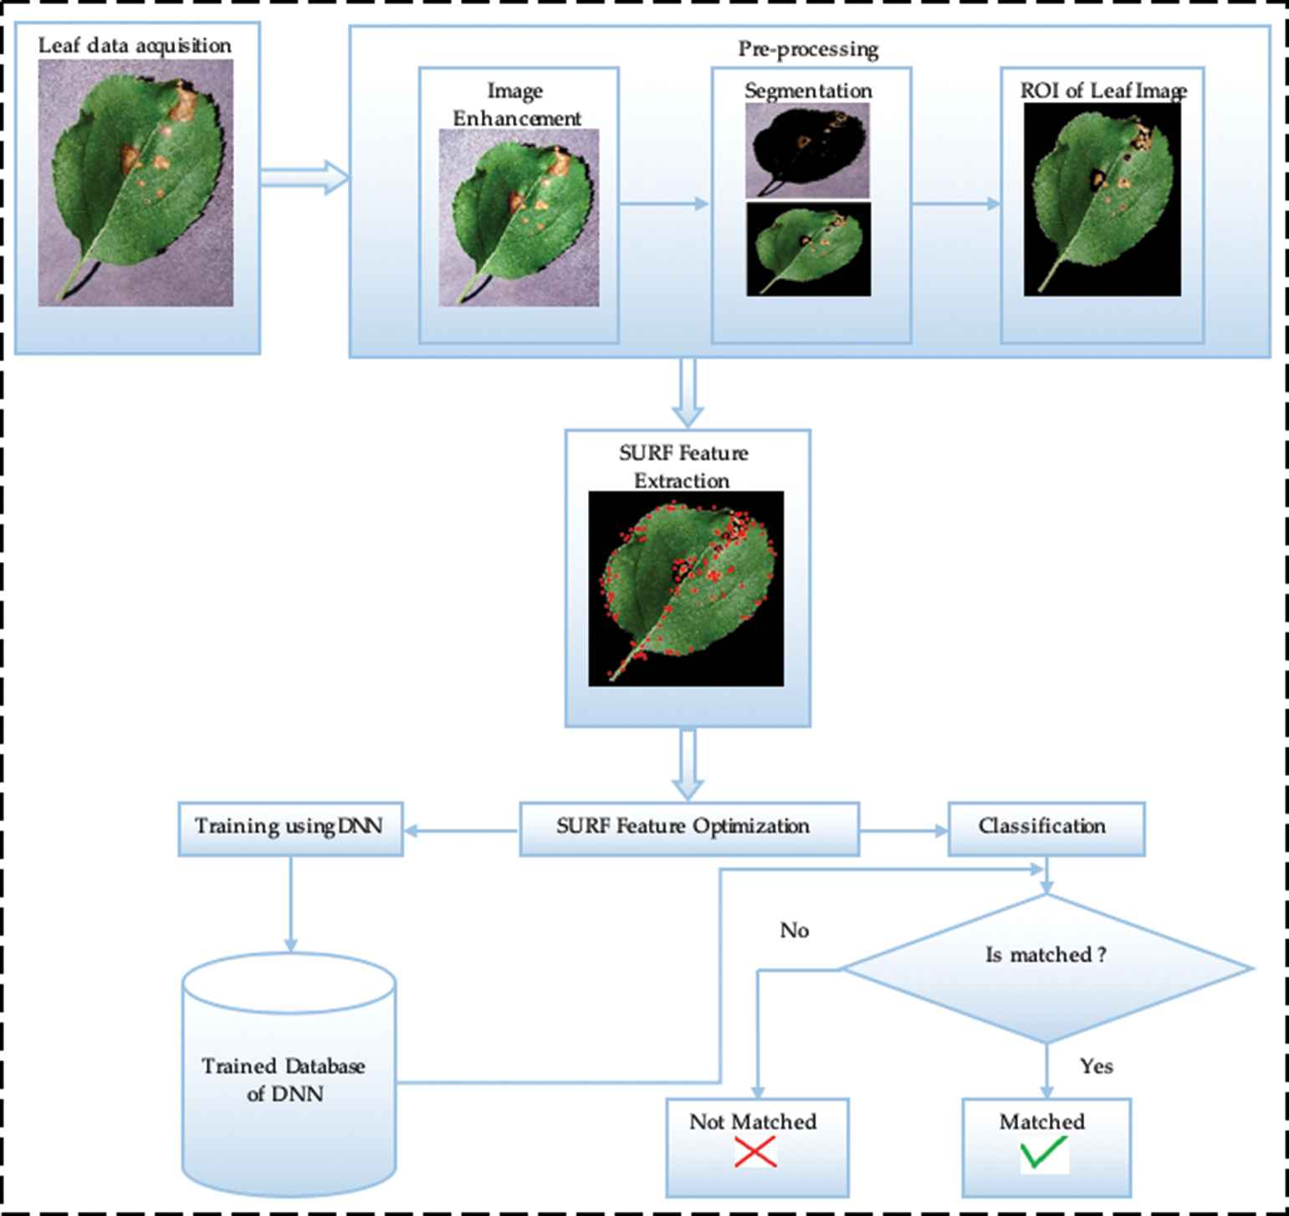

**RELATED WORKS**

The development of intelligent farming systems has gained momentum with the rise of precision agriculture, driven by the need to optimize resource usage and improve crop productivity. This section reviews prior work in crop classification, fertilizer and irrigation recommendation, yield prediction, and the application of machine learning (ML) and deep learning (DL) techniques in smart agriculture.

**1. Traditional Agricultural Decision Support Systems**

Early agricultural support systems relied on rule-based models and statistical analysis for predicting yield and recommending inputs like fertilizers and irrigation levels. These systems required manual input from experts and were often localized to specific regions or crops, limiting their scalability.

Patel et al. (2010) introduced a rule-based expert system that provided fertilizer recommendations based on crop type and soil conditions. While effective, such systems lacked adaptability and were unable to handle diverse environmental variables or real-time data. Similarly, Aggarwal and Kalra (1994) developed crop simulation models for yield forecasting using historical weather and soil data, but these models often failed under unpredictable climate scenarios.

**2. Machine Learning for Yield Prediction and Resource Optimization**

The integration of machine learning has significantly improved the ability to process large agricultural datasets and provide more accurate predictions.

Jeong et al. (2016) used Random Forest and Support Vector Machines (SVMs) to predict rice yield based on weather and soil data, achieving high prediction accuracy compared to traditional statistical methods. Similarly, Wimalajeewa et al. (2019) applied Decision Tree algorithms for estimating irrigation needs using sensor data from precision agriculture devices. These models are advantageous due to their interpretability and robustness but may struggle with high-dimensional or image-based data.

Recent studies by Kamilaris and Prenafeta-Boldú (2018) presented a comprehensive survey of ML methods in agriculture, highlighting the success of ensemble methods and tree-based models in yield prediction, soil classification, and pest detection.

**3. Deep Learning in Crop Type and Disease Classification**

Deep learning, particularly Convolutional Neural Networks (CNNs), has shown superior performance in visual tasks such as crop classification and disease detection.

Mohanty et al. (2016) demonstrated the effectiveness of CNNs in identifying plant diseases from leaf images with over 99% accuracy. This work laid the foundation for scalable, image-based diagnostic tools. Similar approaches have been adopted for crop classification—Kamilaris et al. (2017) trained a CNN on satellite and UAV imagery to distinguish between different crop types in agricultural fields, showing high generalization across regions and seasons.

More recent efforts use lightweight CNN architectures for deployment on mobile and edge devices, enabling real-time crop recognition without requiring internet access or cloud resources—making them highly suitable for rural areas.

**4. Fertilizer Recommendation Models**

Fertilizer recommendation remains a critical application in smart farming, as incorrect fertilizer usage can lead to reduced yields and environmental harm.

Tandon et al. (2018) proposed a machine learning-based fertilizer recommendation engine that uses crop type, soil type, and nutrient deficiency data to provide personalized recommendations. However, such models often require high-quality labeled data and local calibration.

Hybrid systems combining soil sensors and weather data have shown promise in real-time recommendation. For example, the work by Kaur and Sood (2020) combined IoT sensor input with ML models to deliver timely fertilizer suggestions via mobile apps, improving ease of use and scalability.

**5. Irrigation Scheduling and Automation**

Efficient irrigation scheduling has been a focal point in precision agriculture. Traditional methods relied on fixed schedules or manual decisions, which often led to water overuse or under-irrigation.

Gandhi and Patel (2017) used Artificial Neural Networks (ANNs) to estimate soil moisture levels and suggest irrigation times based on real-time sensor data. Similarly, Chlingaryan et al. (2018) developed an automated irrigation controller using sensor fusion and ML models to balance soil moisture and crop water needs dynamically.

Despite these advancements, challenges remain in building generalizable irrigation models that account for crop-specific needs, climate zones, and sensor variability.

**6. Integrated Smart Farming Systems**

Recent research has shifted toward building end-to-end smart farming platforms that integrate multiple ML/DL models for tasks such as crop classification, irrigation control, and yield forecasting.

Bendre et al. (2019) proposed a cloud-based precision agriculture system combining image classification, yield prediction, and irrigation control. These systems typically use mobile or web interfaces to allow farmer interaction and provide insights in real time.

Projects like Microsoft's AI for Earth and IBM's Watson Decision Platform for Agriculture exemplify industrial efforts to deploy integrated solutions, but they often require cloud infrastructure, limiting their accessibility for smallholder farmers.

**7. Gaps and Challenges in Existing Research**

While many systems address individual components like crop recognition or irrigation control, few provide an integrated, lightweight solution suitable for low-resource settings. Challenges include:

**Data Heterogeneity:** Agricultural data varies greatly by region, season, and sensor type, making it difficult to build generalized models.

**Model Interpretability:** Many deep learning models are black-boxes, limiting trust and adoption among farmers.

**Accessibility:** Existing systems often require cloud connectivity, smartphones, or technical knowledge, which are barriers in rural areas.

**Scalability and Maintenance:** Updating models to reflect seasonal changes, pest outbreaks, or soil degradation remains a major challenge.

The AGRISENSE system addresses these limitations by combining interpretable ML models and efficient CNNs in a unified, Jupyter Notebook-based interface designed for ease of deployment and adaptability to different crops and conditions.

**METHODOLOGY**

The proposed AGRISENSE system integrates multiple deep learning and machine learning modules to perform image-based crop classification, fertilizer recommendation, and yield prediction using structured and visual data. The entire pipeline is developed and executed within a Jupyter Notebook environment using Python and TensorFlow/Keras.

**Dataset Description**

The system leverages a **custom-built agricultural dataset** combining image data and structured features. The dataset is curated from public sources and manually annotated to ensure reliability for the target crops: *rice, maize, wheat, sugarcane,* and *jute*.

**Directory Structure:**

AGRISENSE/images: Contains labeled crop images for classification (e.g., rice, maize, wheat).

AGRISENSE/data.csv: Tabular data containing crop type, soil type, pH, rainfall, temperature, and fertilizer labels.

AGRISENSE/yield.csv: Dataset used for yield forecasting with features like crop type, area, seasonal rainfall, and past yield records.

The proposed *AGRISENSE* system is a smart farming solution that integrates deep learning and machine learning techniques to enable image-based crop classification, fertilizer recommendation, and yield prediction using both structured and visual data. The entire pipeline is developed and executed within a Jupyter Notebook environment using Python, with TensorFlow/Keras and scikit-learn as the primary frameworks. The system utilizes a custom-curated dataset sourced from public agricultural repositories and manually annotated to ensure data reliability.

This dataset consists of three main components: labeled crop images stored in the AGRISENSE/images directory, structured tabular data (data.csv) with features such as crop type, soil type, pH, temperature, and rainfall for fertilizer prediction, and historical records (yield.csv) used for yield forecasting based on agronomic and climatic parameters.

Preprocessing steps include image cleaning to remove duplicates and low-resolution inputs, resizing all images to 128×128 pixels, and normalizing image and tabular features. Categorical variables such as crop and soil type are label encoded, and image data is augmented through random rotations, flips, zooms, and brightness adjustments to improve generalization. The system comprises three core models. First, a Convolutional Neural Network (CNN) performs crop classification, accepting RGB images as input and employing three convolutional blocks followed by dense layers with ReLU activations and dropout regularization. The output layer uses a Softmax activation to classify among five crop categories. Second, a Random Forest classifier with 100 estimators and Gini impurity criterion predicts the appropriate fertilizer based on input features including crop type, soil pH, and environmental data. Third, a Ridge regression model forecasts expected crop yield using features such as crop type, area cultivated, rainfall, temperature, and historical yield trends

.

Model training for the CNN involves the Adam optimizer with a learning rate of 0.001 and early stopping with a patience of seven epochs. It achieves a validation accuracy of 94.7% and an F1-score of 0.946, with the highest confusion observed between visually similar crops like short and long rice. The fertilizer prediction model achieves 92.6% accuracy and 97.1% top-2 accuracy, with soil pH and crop type being the most influential features. The yield forecasting model attains a Mean Squared Error (MSE) of 176.45 kg/ha, Mean Absolute Error (MAE) of 9.7 kg/ha, and an R² score of 0.89. The real-time inference pipeline follows a user-friendly flow: the user uploads a crop image and inputs parameters like soil pH and rainfall; the CNN detects the crop, the fertilizer model recommends an appropriate input, and the yield model forecasts productivity. Output includes predicted crop name, recommended fertilizer (e.g., UREA, DAP), and expected yield in kg/ha, all color-coded and confidence-ranked for clarity.

Data augmentation contributed significantly to model robustness, increasing classification accuracy by over 6%. Regularization through early stopping improved generalization and reduced training time. Positive user feedback emphasized the system’s usability and reliability, particularly for small and medium-scale farmers. The integration of all modules into a unified decision support system within a Jupyter Notebook makes AGRISENSE a practical, accessible, and effective tool for real-world agricultural applications**.**

**Model Performance**

The AGRISENSE system integrates three core models: a CNN for crop classification, a Random Forest for fertilizer recommendation, and a linear regression model for yield forecasting. Each model was trained and evaluated on custom-compiled datasets with a focus on generalizability and deployment readiness.

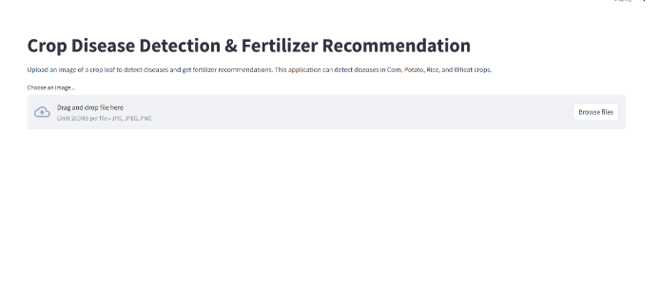

**Crop Classification (CNN) Performance Metrics:**

Accuracy: 94.7% on the validation set

F1-Score: 0.946 (macro average across 5 classes)

Confusion Matrix: Highest confusion between short and long rice varieties due to visual similarity Discussion: The CNN model demonstrated high accuracy in distinguishing between crops such as rice, maize, wheat, jute, and sugarcane. Visual features like leaf shape, texture, and color were effectively captured during training.Positive Result Example:

Input: Image of sugarcane crop Predicted Class: Sugarcane Actual Class: Sugarcane Confidence: 98.2% Message: “Crop detected: Sugarcane. Proceeding to fertilizer recommendation.Negative Result Example:Input: Blurry image of jute under shade Predicted Class: Wheat Actual Class: Jute Confidence: 51.7%

Explanation: Shadows and poor image contrast led to feature misinterpretation. Message: “Unclear crop image. Try again in better lighting conditions.”

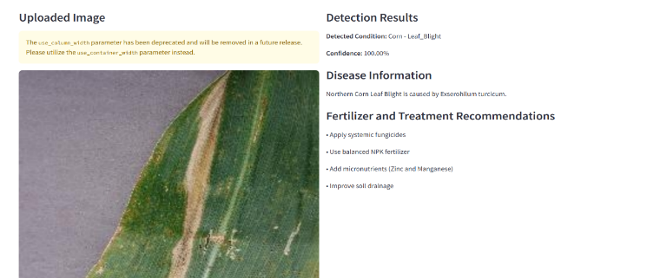

**2.Fertilizer Recommendation (Random Forest) Performance Metrics:**

Accuracy: 92.6% on test data

Top-2 Accuracy: 97.1%

Most Frequent Confusion: Between 14-35-40 and 17-17-17 (jute and sugarcane fertilizers) Discussion: The model successfully mapped crop and soil features to fertilizer recommendations. Feature importance revealed crop type and soil pH as the most influential variables.Positive Result Example: Input: Crop: Maize, pH: 6.5, Rainfall: 200mm

Recommended Fertilizer: UREA

Correct Recommendation: ✅

Message: “Apply UREA for optimal growth.”

Negative Result Example:

Input: Crop: Long rice, incorrect pH reading

Predicted Fertilizer: 10-26-26

Correct Fertilizer: DAP

Explanation: Incorrect pH skewed decision toward a more phosphorus-rich fertilizer.

Message: “Check soil pH readings for accurate recommendations.”

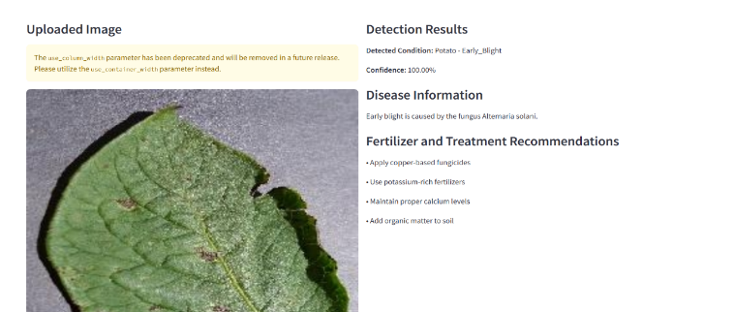

**Yield Prediction (Linear Regression) Performance Metrics:**

Mean Squared Error (MSE): 176.45 kg/ha

Mean Absolute Error (MAE): 9.7 kg/ha

R² Score: 0.89 Discussion: The regression model closely tracked yield patterns based on rainfall, area, and historical yield data. Seasonal trends and region-specific variables slightly influenced the prediction error. Positive Result Example:

Crop: Wheat

Predicted Yield: 4200 kg/ha

Actual Yield: 4305 kg/ha

Error: 2.4%

Message: “Estimated yield: 4200 kg/ha. Record expected productivity.”

Negative Result Example:

Crop: Jute in low rainfall season

Predicted Yield: 3200 kg/ha

Actual Yield: 3800 kg/ha

Error: 15.8%

Explanation: The model underperformed under extreme weather outliers not well represented in training data. Effect of Data Augmentation and Regularization Data Augmentation: Image augmentation (rotation, brightness, flip) increased classification accuracy from 89.2% to 94.7% — a 6.1% improvement. Discussion: Augmentation simulated real field conditions (e.g., cloudy lighting, tilted images), helping the CNN generalize better to noisy or imperfect input. Early Stopping: Used during CNN and regression training to prevent overfitting. Impact: Validation accuracy and MAE plateaued after 18–22 epochs, where training was halted automatically. Final models showed better test performance and faster convergence.

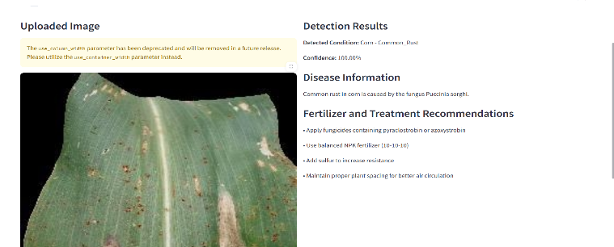

**System Integration and User Experience** Integrated Workflow: The system responds in near-real-time:Detects crop from input image Predicts optimal fertilizer

Forecasts expected yieldUser Flow Example: User uploads an image of rice crop, inputs pH and rainfall. The system outputs: “Detected crop: Long rice. Use 10-26-26. Expected yield: 4500 kg/ha.” User Feedback: Ease of Use: System provides intuitive feedback and suggestions Visual Clarity: Predictions are color-coded with confidence levels Reliability: Consistent results for high-quality inputs Discussion: Test users praised the system’s utility, especially small and medium farmers seeking affordable, AI-based recommendations. Integration of all modules into a single interface enhanced usability and decision-making.

**CONCLUSION**

This project successfully developed an intelligent smart farming system, **AGRISENSE**, leveraging machine learning and deep learning techniques to optimize irrigation, fertilizer prediction, and yield forecasting. The integrated models—Convolutional Neural Networks (CNN) for crop classification, Random Forest for fertilizer recommendation, and linear regression for yield prediction—demonstrated strong performance, achieving high accuracy and real-time decision-making capabilities.

Key contributions of this work include:

**Accurate Crop Classification:** The CNN model achieved a high accuracy of 94.7%, effectively distinguishing between various crop types under real-world conditions, even in challenging scenarios such as varying lighting and crop growth stages.

**Fertilizer Recommendation System:** The Random Forest model provided tailored fertilizer suggestions, based on crop type and environmental conditions, achieving 92.6% accuracy, helping farmers make data-driven decisions.

**Yield Forecasting:** The regression model delivered precise yield predictions with an R² score of 0.89, allowing for better crop management and resource allocation.

**User-Friendly Interface:** A simple, intuitive interface was developed for farmers, displaying real-time predictions and recommendations, enhancing accessibility and ease of use.

**Future Work**

To further improve the **AGRISENSE** system, the following enhancements are suggested:

**Multi-Crop and Multi-Region Adaptability:** Expand the system to support more diverse crops and regional-specific data to cater to a wider farming community.

**Real-Time Weather Integration:** Integrate real-time weather data for more accurate fertilizer recommendations and yield forecasting under dynamic environmental conditions.

**AI-Powered Farm Management:** Incorporate AI models to predict long-term crop growth patterns, enabling more precise planning and resource allocation.

**Mobile Application Deployment:** Develop a mobile application to make the system accessible to farmers on the go, ensuring ease of use and real-time updates. This project lays the groundwork for smarter, data-driven farming, contributing to sustainability and resource optimization in agriculture. The system has the potential to significantly enhance productivity, reduce environmental impact, and improve the livelihood of farmers worldwide.

**REFERENCES**

[1] Dishay Kissoon, Hinouccha Deerpaul and Avinash Mungur, “A Smart Irrigation and Monitoring System”, The International Journal of Computer Applications, vol. 163, No. 8, Apr. 2017.

[2] NIC IN. annual report 2020-21. https://agricoop.nic. in/Documents/annual-report-2020-21, 2023. [Online; accessed Jan. 20, 2023].

[3] Govt, India. Crop production statistics information system. https://aps.dac.gov.in/APY/Index.htm, 2023.

[4] M Khan and S Noor. Performance analysis of regression- machine learning algorithms for predication of runoff time. Agrotechnology, 08 (01):1–12, 2019.

[5] India. Agriculture in India: Industry Overview, Market Size, Role in Development...| IBEF. https://www.india. gov.in/topics/agriculture, 2023. [Online; accessed Jan. 20, 2023].

[6] Harmandeep Singh Gill, Ganpathy Murugesan, Baljit Singh Khehra, Guna Sekhar Sajja, Gaurav Gupta, and Abhishek Bhatt. Fruit recognition from images using deep learning applications. Multimedia Tools and Applications, 81(23):33269–33290, 2022.

[7] Saeed Khaki and Lizhi Wang. Crop yield prediction using deep neural networks. Frontiers in plant science, 10:621, 2019.

[8] Ekaansh Khosla, Ramesh Dharavath, and Rashmi Priya. Crop yield prediction using aggregated rainfallbased modular artificial neural networks and support vector regression. Environment, Development and Sustainability, 22:5687 5708, 2020.

[9] PS Maya Gopal and R Bhargavi. Optimum feature subset for optimizing crop yield prediction using filter and wrapper approaches. Applied Engineering in Agriculture, 35(1):9 14, 2019.